NAME ……………………….……………………….INDEX ……..…….……/…..…

ADM NO:………………….……….CLASS:……………..SIGNATURE:……………



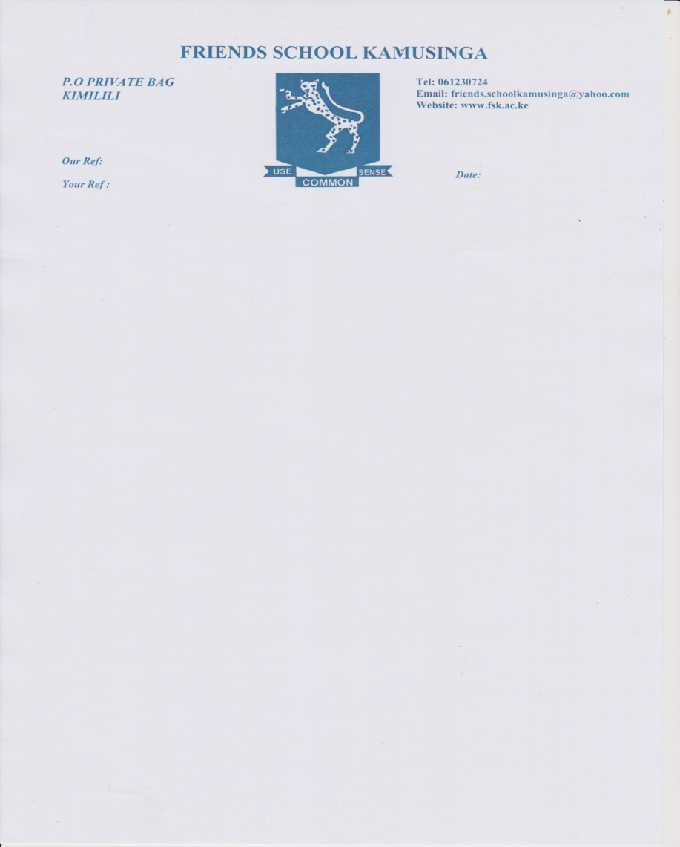

Form Four

101/3

ENGLISH

Paper 3

(Creative Composition and Essay Based On Set Texts)

BRISINGA EXAMINATION

**Kenya Certificate of Secondary Education**

**Form Four**

101/3

English PAPER 3

(Creative Composition and Essay Based on set Texts)

2024

2 HOURS 30 MINS

**INSTRUCTIONS TO CANDIDATES**

* Answer **three** questions only
* Question **one** and **two** are compulsory
* In question **three** choose only **one** of the questions from the texts you have prepared on.
* Where a candidate presents work on **more** than **one** optional text only the first one to appear will be marked.
* Each of your essays must not exceed **450** words.
* This paper consists of **2** printed pages.

**MAG IN AT I VE COMP OS I T I ON (20 MARKS)**

**Either**

a) Write a composition that ends with the following statement ...it is absolutely true that better the devil you know than the angel you don't know.

**Or**

b) Write a composition on the effects of drugs and substance abuse and explain what the youth of Kenya can do to curb it.

**2. T HE COMP ULSORY S ET T EXT. (20 MARKS)**

**John Lara-The Samaritan**

Unity yields positive success. However, those who conspire to do evil for their own egocentric gains end up failing causing misery to themselves or other people. With close reference to John Lara's The Samaritan, write an essay to validate the truth of this statement.

**T HE OPT I ON AL S ET T EXT S (20 MARKS)**

**Either**

1. **Short Story**

**Godwin Shiundu - *A Silent Song and Other Stories***

"People who are physically handicapped face various challenges in life." Write an essay to show the truth of this statement using illustrations from Leonard Kibera's story a Silent Song

**Or**

**Play**

1. **Adipo Sidang- *Parliament of Owls***

"Sycophancy can sometimes be confused with loyalty." Using illustrations from Adipo Sidang's Parliament of Owls , write a composition to show the validity of this saying.

**Or**

**Novel**

c) **Kazuo Ishiguro- *An Artist of the Floating World***

"Memories of the past can make one change his lifestyle. With illustrations from Kazuo Ishiguro's novel, An Artist of the Floating World, write an essay highlighting these memories and how they affect people’s lives.